BETTER TOGETHER in 2022
May 22, 2022
Brian Hummel, Executive Pastor
Reforesting Faith
Shade
Matthew 6:25:33, Psalm 91

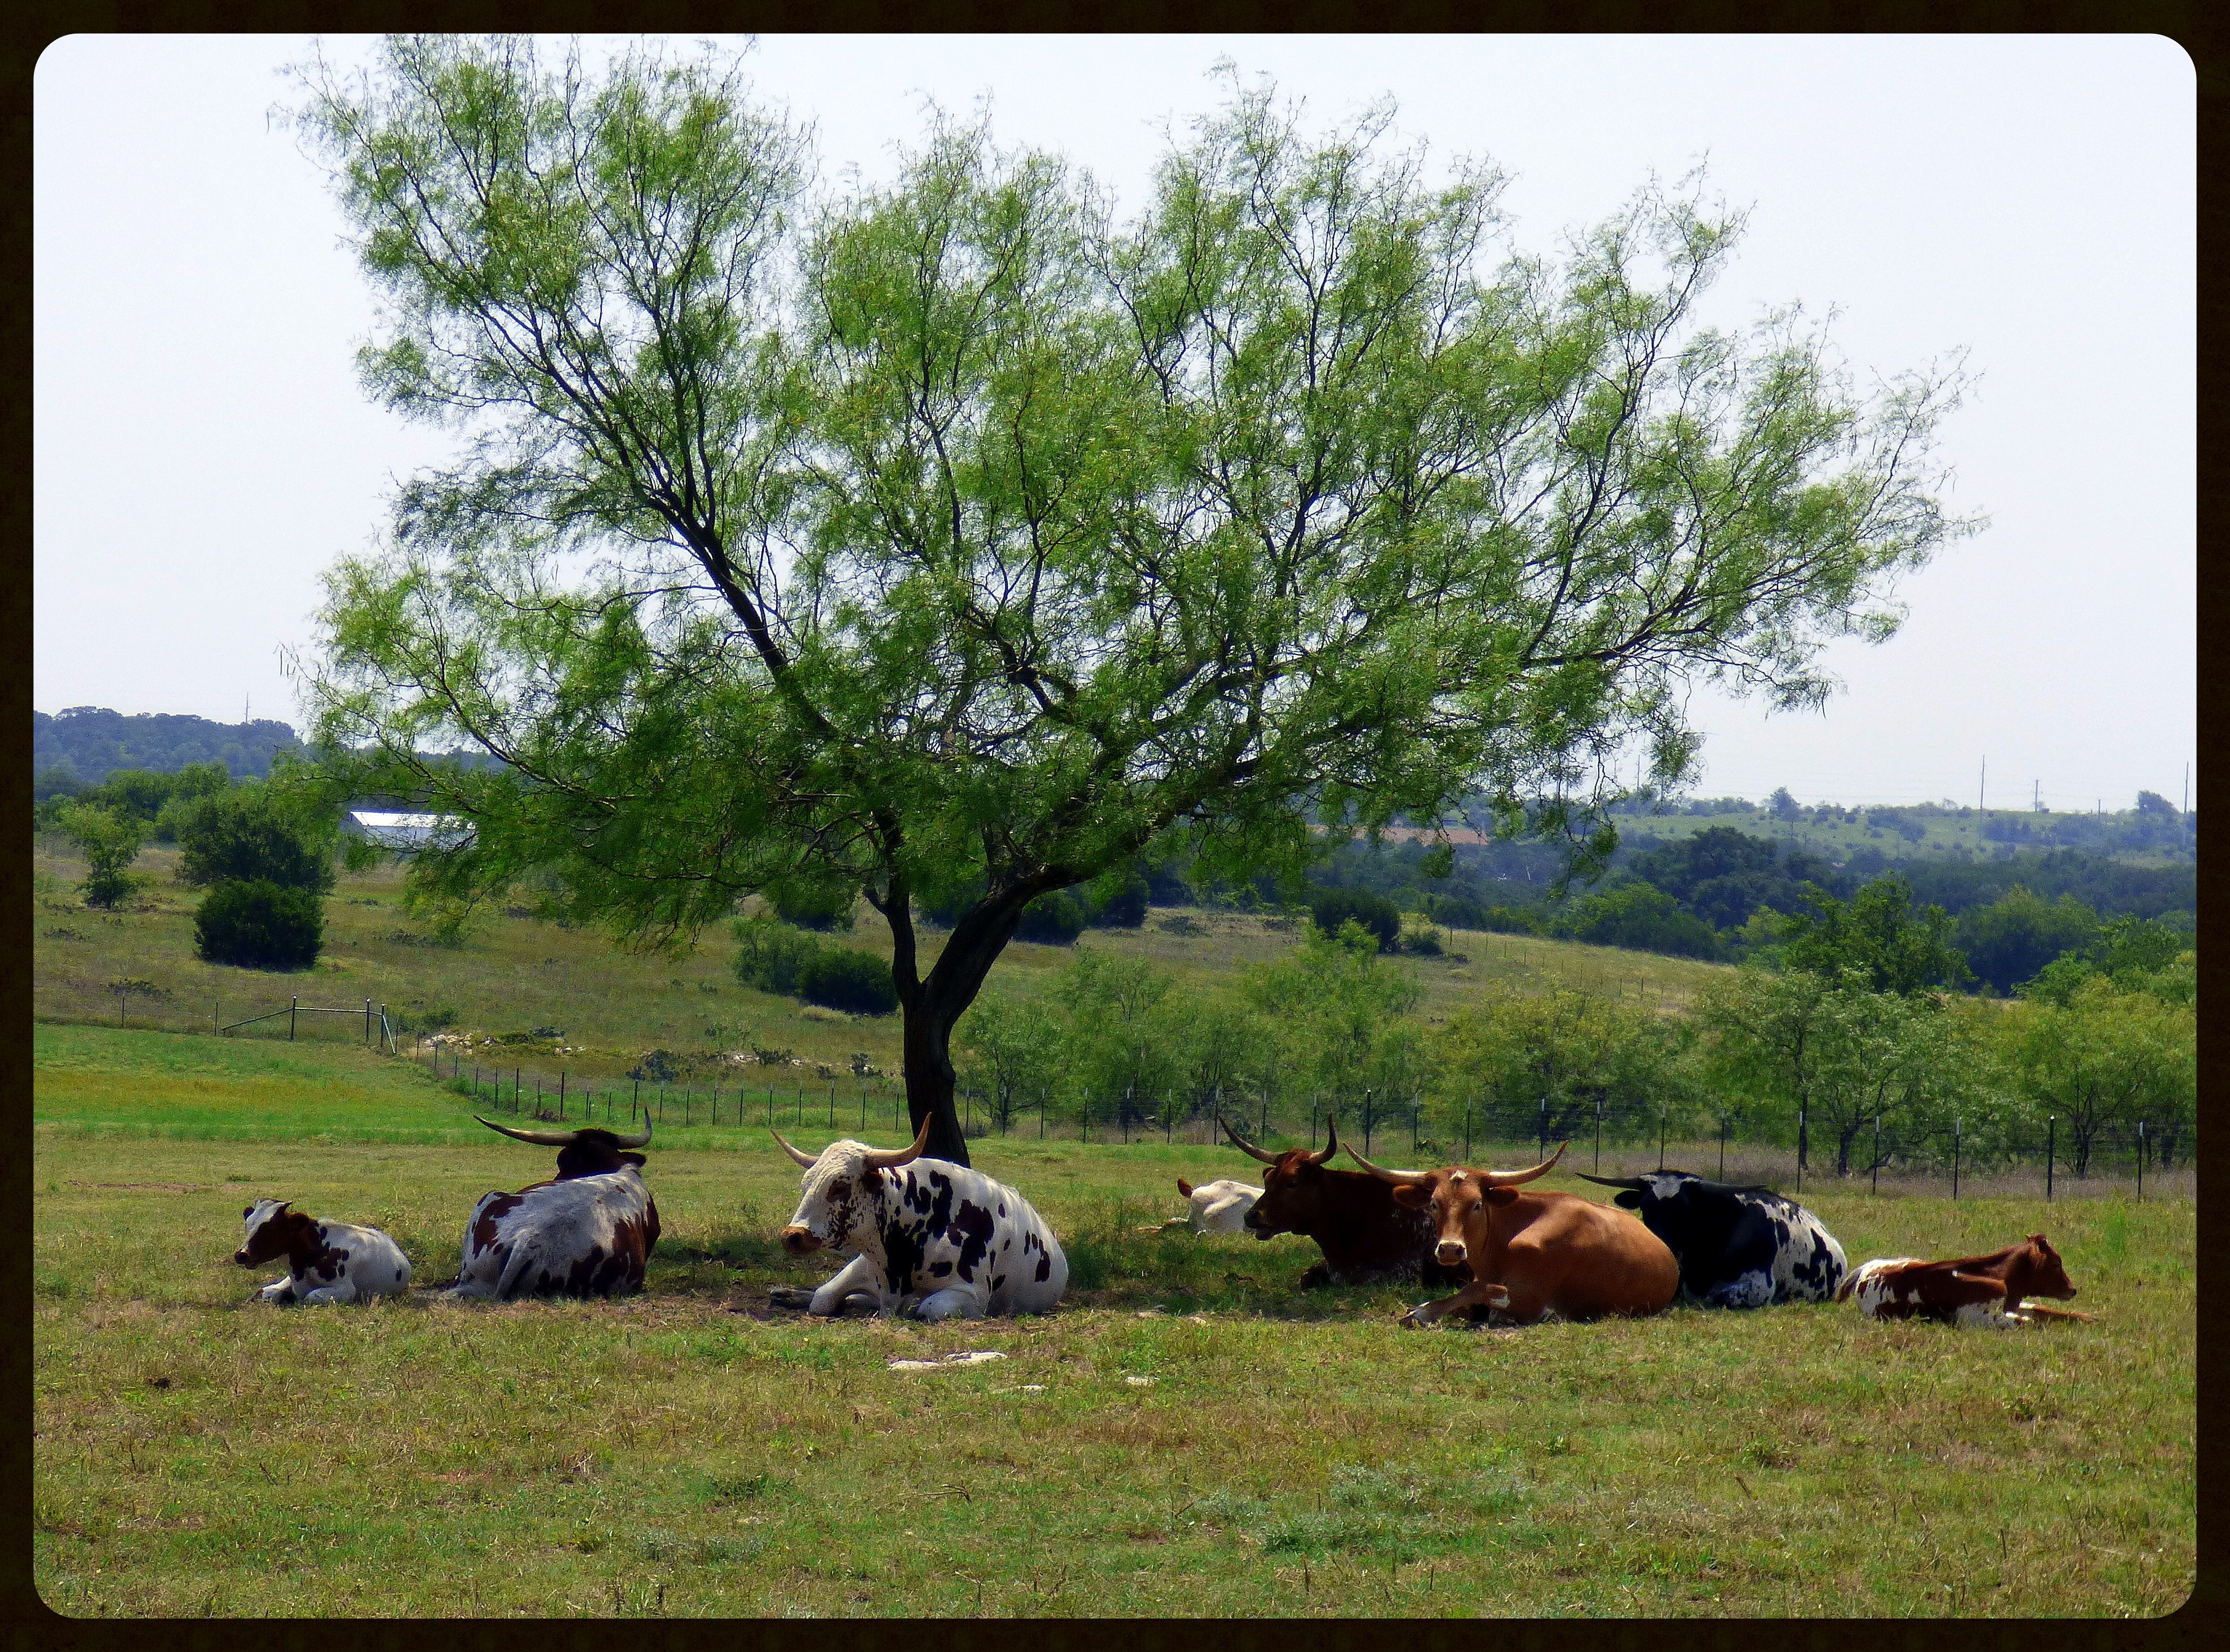

We seek shade and shelter from the harshness in our lives.

We live in a harsh world.

In this world you will have trouble.
John 16:33

We rarely reach the ideal of the early church:

All the believers were one in heart and mind. No one claimed any of their possessions was their own, but they shared everything they had.
Acts 4:32

More often, we experience the curse that has been spoken on this world.
Cursed is the ground because of you; through painful toil you will eat from it all the days of your life. It will produce thorns and thistles for you…until you return to the ground…and dust you will return.
Genesis 3:17-19

We tend to thoughtlessly react by seeking the quickest, easiest reprieve we can find.

The problem is the shade we seek is often shifting shadows.

Every good and perfect gift is from above, coming down from the Father of the heavenly lights, who does not change like shifting shadows.
James 1:17

Stressful day at the office – mindless TV or Instagram reels
Fight with your spouse – maybe you run to the fridge – food? alcohol?
Marriage struggling – maybe you look outside of your marriage
Anxiety / Worry – withdraw from friends and loved ones.

Often the shifting shadows bring immediate relief, but there are long term consequences.

Shifting shadows can become false gods – idols in our life.

We see this in scripture over and over again:
- Adam and Eve
- Moses disobeying God – Numbers 20:1-13
- David with Beersheba – 2 Samuel 11

Jesus teaches us about this in Matthew 6, starting in verse 25:

“Therefore I tell you, do not be anxious about your life, what you will eat or what you will drink, nor about your body, what you will put on. Is not life more than food, and the body more than clothing? Matthew 6:25

The problem isn’t our need for food or drink, our health, our clothes – the problem is our anxiousness about them.
Our anxiousness drives us to shifting shadows for relief.

Look at the birds of the air: they neither sow nor reap nor gather into barns, and yet your heavenly Father feeds them. Are you not of more value than they? And which of you by being anxious can add a single hour to his span of life? And why are you anxious about clothing? Consider the lilies of the field, how they grow: they neither toil nor spin, yet I tell you, even Solomon in all his glory was not arrayed like one of these. Matthew 6:26-29

The instruction might seem contradictory to the truths found elsewhere in scripture: The law of sowing and reaping, or the instruction to work hard in Proverbs 6 but these hold true. Jesus is pointing us to what is most important.

But if God so clothes the grass of the field, which today is alive and tomorrow is thrown into the oven, will he not much more clothe you, O you of little faith? Therefore do not be anxious, saying, ‘What shall we eat?’ or ‘What shall we drink?’ or ‘What shall we wear?’ For the Gentiles seek after all these things, and your heavenly Father knows that you need them all. Matthew 30-32

Find rest in the shade of the creator.

He who dwells in the shelter of the Most High will abide in the shadow of the Almighty. I will say to the Lord, my refuge and my fortress, my God, in whom I trust.
Psalm 91:1-2

For you have been a stronghold to the poor, a stronghold to the needy in his distress, a shelter from the storm and a shade from the heat;
Isaiah 25:4

The Lord is my rock and my fortress and my deliverer, my God, my rock, in whom I take refuge, my shield, and the horn of my salvation, my stronghold.
Psalm 18:2

But seek first the kingdom of God and his righteousness, and all these things will be added to you.
Matthew 6:33

Seek first the Kingdom of God:

- Realize that there is a Kingdom.

Entry to this Kingdom comes only through faith in Jesus Christ.

Jesus answered him, “Truly, truly, I say to you, unless one is born again he cannot see the kingdom of God.”
John 3:3

- Realize that the Kingdom has a King – and you are not it.

You shall walk after the Lord your God and fear him and keep his commandments and obey his voice, and you shall serve him and hold fast to him.
Deuteronomy 13:4

- Change your perspective.

For this light momentary affliction is preparing for us an eternal weight of glory beyond all comparison.
2 Corinthians 4:17

