**BETTER TOGETHER** in 2022

May 15, 2022

Joe Carollo, Lead Student Pastor

**Reforesting Faith**

**Reach**

Jeremiah 17:8



”everyone who is called by my name, whom I **created for my glory**, whom I formed and made.” Isaiah 43:7

“To glorify God is to exalt His attributes—His holiness, faithfulness, mercy, grace, love, majesty, sovereignty, power, and omniscience, to name a few—rehearsing them over and over in our minds and telling others about the singular nature of the salvation only He offers.”

For his invisible attributes, namely, his eternal power and divine nature, have been clearly perceived, ever since the creation of the world, **in the things that have been made**. So they are without excuse. Romans 1:20

We must go **deep** to grow **tall**.

Spiritual **roots** are essential to the life of every believer.

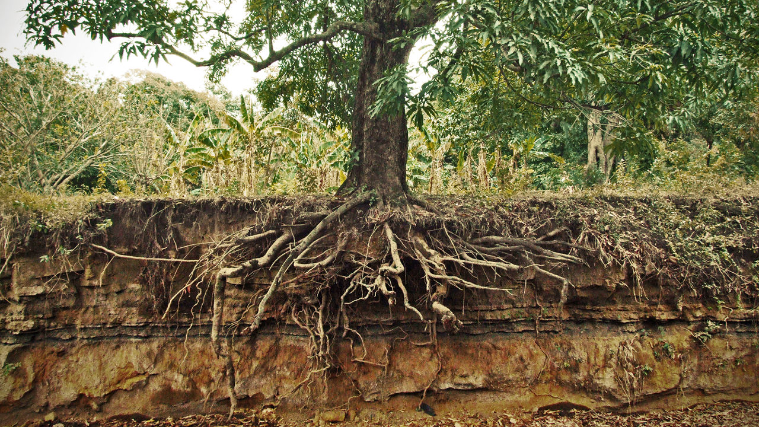

In order to grow tall, we must go deep and reach for **living** water.

*Jesus answered her, “If you knew the gift of God, and who it is that is saying to you, ‘Give me a drink,’ you would have asked him, and* ***he would have given you living water****.”* John 4:10

Have you ever been thirsty?

As a deer pants for flowing streams, so pants my soul for you, O God. Psalm 42:1

Parent your kids **towards** living water.

For my thoughts are not your thoughts, neither are your ways my ways, declares the Lord. Isaiah 55:8

Do not swap God’s **great** for Our good.

... But seek ye first the kingdom of God, and his righteousness; and all these things shall be added unto you. Matthew 6:33. King James Version

Reach **wide** to stand firm.

**Heart roots** – the spiritual root of prayer that connects our hearts with the Father.

**Lateral roots** – the spiritual root of community which forms support through connection and provides nourishment for our soul.

Then the Lord God said, “It is not good that the man should be alone; I will make him a helper fit for him.” Genesis 2:18

He is like a tree planted by water, that sends out its roots by the stream, and does not fear when heat comes, for its leaves remain green, and is not anxious in the year of drought, for it does not cease to bear fruit.” Jeremiah 17:8

**Sinker roots** – the spiritual root that goes deep in to God’s Word.

So faith comes from hearing, and hearing through the word of Christ. Romans 10:17

7

“For there is hope for a tree, if it be cut down, that it will sprout again, and that its shoots will not cease. Though its root grow old in the earth, and its stump die in the soil, yet at the scent of water it will bud and put out branches like a young plant. Job 14:7-9 ESV