BETTER TOGETHER in 2022
JANUARY 2, 2022
Dr. Jerry Edmonson, Lead Pastor
YOU ARE HERE!

Where are you? Right now … at this moment?

Do you know where you are?

Do you know where you are going?

If you shoot for nothing … you will hit it every time!

Do you trust the route?

Fully commit to the shot. If you hesitate, doubt or for a moment not believe that God is fully with you and for you … do not do it!

But whoever has doubts is condemned if he eats, because the eating is not from faith. For whatever does not proceed from faith is sin. Romans 14:23

Do you trust the One who is giving you the route?

What happens if you make a wrong turn?

Rerouting your journey!

So, are you where you want to be right now … spiritually, emotionally, relationally? Are there areas in your life that you need to grow in? You need to be a better husband, wife, friend, mom, dad? You need to take care of your body better, you need to eat better, you need to read more, trust God more, pray more, carve out time and space to be still and listen to the Lord? But you have given into the noise.

Make me to know your ways, O Lord; teach me your paths. Lead me in your truth and teach me, for you are the God of my salvation; for you I wait all the day long. Psalm 25:4–5

Trust in the Lord with all your heart, and do not lean on your own understanding. In all your ways acknowledge him, and he will make straight your paths. Proverbs 3:5–6

Your Spiritual GPS – God - Personal - Social

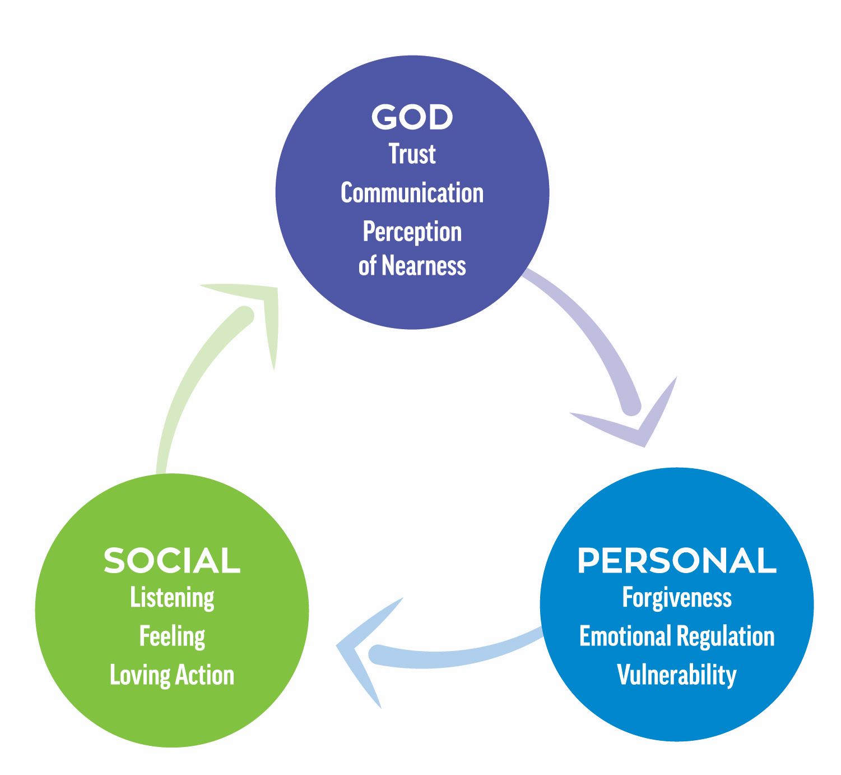
https://soul-metrics.com/

I took this inventory on spiritual health to try it out and see if it would show some things in my own life that I need to work on … and it did!

You have to know where you are and where you want to go in order to determine a way to get to your destination.

Where are you in your relationship with God?

You make known to me the path of life; in your presence there is fullness of joy; at your right hand are pleasures forevermore. Psalm 16:11

Your Spiritual GPS might lead you to … read God’s word every day this year.

God has spoken; the question is … are you listening? Commit to reading the scriptures.

I have stored up your word in my heart, that I might not sin against you. Psalm 119:11

Your word is a lamp to my feet and a light to my path ... give me life, O Lord, according to your word! Psalm 119:105,107b
Where are you in your personal life?

Come to me, all who labor and are heavy laden, and I will give you rest. Take my yoke upon you, and learn from me, for I am gentle and lowly in heart, and you will find rest for your souls. For my yoke is easy, and my burden is light.” Matthew 11:28–30

Finally, brothers, whatever is true, whatever is honorable, whatever is just, whatever is pure, whatever is lovely, whatever is commendable, if there is any excellence, if there is anything worthy of praise, think about these things. Philippians 4:8

Your Spiritual GPS might lead you to … take Faithwalking this year and begin your journey toward personal transformation.

Where are you in your relationship with others?

A new commandment I give to you, that you love one another: just as I have loved you, you also are to love one another. By this all people will know that you are my disciples, if you have love for one another.” John 13:34–35

Your Spiritual GPS might lead you to … build a friendship this year with someone who is different than you.

In 2022, what if you and I focused on the truth that we are better together … that we are to encourage one another in these three areas.

Are you in?

