RISE UP in 2021
June 27, 2021
Dr. Jerry Edmonson, Lead Pastor

ALL WE NEED
A Study in the book of Colossians
Perfect!
Colossians 1:15-23

Many of us admire perfection when we see it. Something so beautiful it appears flawless. A work of art like the Monalisa.

Nature, stars on a clear night

or a sunrise over the ocean

or sunset behind the mountains on a cloudy evening.

A flower that is perfect in symmetry, color and pattern.

In mathematics, the golden ratio that we see in life.
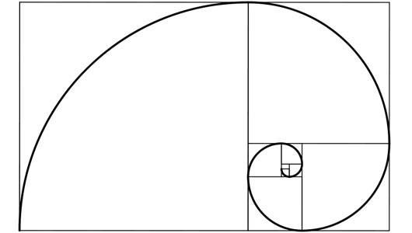

We are drawn to perfection; we applaud perfection; we are in awe of perfection … there is something beautiful about perfection.

Yet, there is a dark side of perfection that robs you of joy. Perfectionism that leads to discontentment in life and the never ending belief that it is not good enough; I am not good enough; they are not good enough … it is just not perfect.

There are many who struggle with perfectionism by believing they and what they do or produce are never good enough … probably because we are not God and we are incapable of true perfection apart from Him.

True perfection only exists in the one who is truly perfect – God.

It took a perfect Jesus dying as a perfect sacrifice to present an imperfect you before a perfect God … now that is perfect.

Jesus Christ is totally unique from every other human being who has ever existed or ever will exist. He is the perfect Adam who became the perfect sacrifice for all of humanity to restore us to God.

But Satan desires to blind the hearts and minds of people concerning Jesus Christ. Satan wants to keep them from really seeing and comprehending who Christ is and what He accomplished when He was crucified on the cross.
What do you see when you look at Jesus?

Jesus is the perfect image of the Father.

He is the image of the invisible God, the firstborn of all creation. Colossians 1:15

eikon - is an image or likeness—such as the emperor’s image on a coin or a child as the image of a parent.

For in him the whole fullness of deity dwells bodily … Colossians 2:9

And whoever sees me sees him who sent me. John 12:45

He(Jesus) is the radiance of the glory of God and the exact imprint of his nature, and he upholds the universe by the word of his power. Hebrews 1:3a

Jesus is the perfect creator of everything.

For by him all things were created, in heaven and on earth, visible and invisible, whether thrones or dominions or rulers or authorities—all things were created through him and for him. And he is before all things, and in him all things hold together. Colossians 1:16-17

Thrones (thronoi) represent the seat of majesty and power.
Dominions (kuriotes) have to do with the authority and power of civil rulers.
Principalities (archai) represent preeminence—that which is before all or above all.
Powers (exousia) have the authority and ability to accomplish things.

All things were made through him, and without him was not any thing made that was made. John 1:3

Jesus said to them, “Truly, truly, I say to you, before Abraham was, I am.” John 8:58

Jesus is the perfect head of the church.

And he is the head of the body, the church. He is the beginning, the firstborn from the dead, that in everything he might be preeminent. Colossians 1:18

“Therefore a man shall leave his father and mother and hold fast to his wife, and the two shall become one flesh.” This mystery is profound, and I am saying that it refers to Christ and the church. Ephesians 5:31–32

Jesus is the perfect reconciler of all things.

For in him all the fullness of God was pleased to dwell, and through him to reconcile to himself all things, whether on earth or in heaven, making peace by the blood of his cross. Colossians 1:19-20

And you, who once were alienated and hostile in mind, doing evil deeds, he has now reconciled in his body of flesh by his death, in order to present you holy and blameless and above reproach before him, Colossians 1:21-22

It is not about you being perfect on your own ... but rather it is about being perfected in Jesus’ perfection.

Jesus is the perfect hope in our lives.

if indeed you continue in the faith, stable and steadfast, not shifting from the hope of the gospel that you heard, which has been proclaimed in all creation under heaven, and of which I, Paul, became a minister. Colossians 1:23

Paul, an apostle of Christ Jesus by command of God our Savior and of Christ Jesus our hope, 1 Timothy 1:1

so that by two unchangeable things, in which it is impossible for God to lie, we who have fled for refuge might have strong encouragement to hold fast to the hope set before us. We have this as a sure and steadfast anchor of the soul, a hope that enters into the inner place behind the curtain, where Jesus has gone as a forerunner on our behalf, … Hebrews 6:18–20

I told you that you would die in your sins, for unless you believe that I am he you will die in your sins.” John 8:24

This Jesus is the stone that was rejected by you, the builders, which has become the cornerstone. And there is salvation in no one else, for there is no other name under heaven given among men by which we must be saved.” Acts 4:11-12

It took a perfect Jesus dying as a perfect sacrifice to present an imperfect you before a perfect God … now that is perfect.

Give your imperfect life over to a perfect Jesus.
Trust Jesus as your perfect sacrifice for all that is imperfect in your life.

Rest in His perfect love for you and find peace in the hope that all things will be made perfect in Jesus.

