RISE UP in 2021
June 20, 2021
Dr. Jerry Edmonson, Lead Pastor

ALL WE NEED
A Study in the Book of Colossians
Oh Happy Day!
Colossians 1:1-14

Where is Colossae?

Colossae was an ancient city in the Lycus River valley, about 100 miles east of the great, cosmopolitan capital city of Ephesus, located in the Roman province of Asia, in present-day Turkey. Colossae was the smallest of three cities in the Lycus Valley -- along with Laodicea (12 miles west) and Hierapolis (15 miles northwest). Each of these cities had Christian churches. There was earthquake around 60 A.D. which destroyed the city and it never recovered.

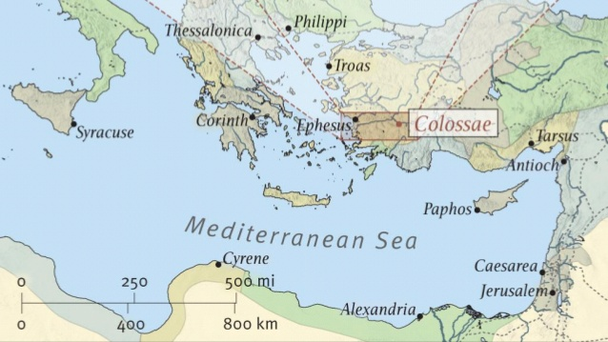

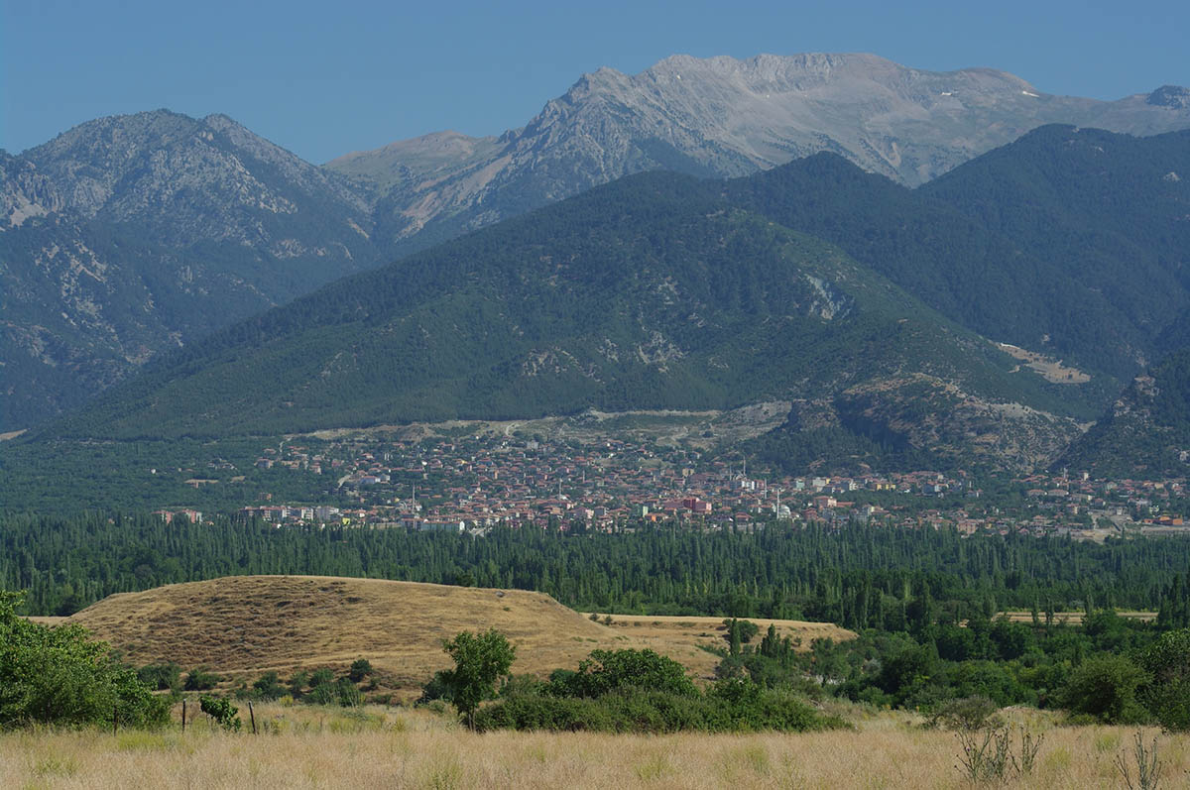
The unexcavated site of Colossae sits near the modern city of Honaz at the base of Mt. Cadmus (in modern Turkey).

Though these cities were far from the big city, they weren't isolated, since they were situated near the great Persian Royal Road that ran from Ephesus and Sardis in the West to the Euphrates and on to Persia in the East. At one point in the fourth or third centuries BC, Colossae had been the most important of the three cities, known for its flourishing textile industry and high-quality dark red wool, known as "Colossian wool." But after the north-south road was moved west to pass through Laodicea, Colossae began to decline.

Roman historian Tacitus mentions an earthquake that destroyed Laodicea in 60-61 AD. Laodicea was rebuilt quickly. We don't know how long it took to rebuild Colossae. Today, however, nothing remains of Colossae above ground. The tell (acropolis or mound) of the city has not been excavated, though the contour of an outdoor amphitheater is discernable on the site.

Who were the Colossians?

The local people were called the Phrygians; they were settlers from Greece, Rome and there was a Jewish community. We know that Antiochus III had settled about 2,000 Jewish families in the general area in 213 B.C. The area still had a strong Jewish minority presence in Paul's day, a fact which probably relates directly to Paul's letter.

Paul, an apostle of Christ Jesus by the will of God, and Timothy our brother, To the saints and faithful brothers in Christ at Colossae: Grace to you and peace from God our Father. Colossians 1:1–2
Why was the problem in the church at Colossae?

The synagogues in that area were noted for lax morals and speculative doctrine. Phrygians were animists – fearful of the spirits of the mountains and the water – which were referred to as the elemental spirits. Romans and Greeks worshipped immoral gods who were far away. Proximity to the nearby highways ensured that the Colossians were exposed to the latest ideas, which then mixed together with other ideas. The Christian church there was subject to syncretism with other religious movements.

Just what is the "Colossian heresy"? As we read between the lines in 2:8-25, we can begin to discern its shape. The heresy seems to have had these elements:

- A belief system, called a "hollow and deceptive philosophy"(2:8).
- Tradition-based, "depends on human tradition"(2:8, 22).
- Elemental spiritual forces underlie the system (2:8).
- Not Christ-centered, the teaching does not "depend on ... Christ"(2:8).
- Food restrictions and Jewish "holy days" are involved (2:16).
- Ascetic disciplines are encouraged (2:18, 23).
- Angel worship is central (2:18).
- Visionary experiences are touted (2:18).
- Pride characterizes the proponents (2:18).
- Losing connection with Christ is the result (2:19).
- Rule-keeping is urged (2:20-23).
- "Fullness" language (1:19; 2:9, 10) suggests that a "fullness" of spiritual experience could not be found in Christ alone. The vocabulary is found in both Gnosticism and Stoicism.
- Circumcision is advocated (2:11, 13; 3:11) -- perhaps.

What is Paul’s overall purpose in writing Colossians?

Colossians seems to have been written with two purposes in mind:

- To encourage and ground new Christians in faith.

- To protect them from the seduction of false teachers.

Probably from a variety of mystical Judaism, which tended to denigrate these Gentile Christians' faith in Christ in favor of the claims of Judaism, along with pagan influence from Roman and Greek Gods.

I want to begin where Paul ends this first part with this simple statement:

We begin with what Jesus has done ... to know the life we are created to live.

He has delivered us from the domain of darkness and transferred us to the kingdom of his beloved Son, in whom we have redemption, the forgiveness of sins. Colossians 1:13–14

This reflects back to the exodus when God delivered the Jewish people for slavery and bondage. Two kingdoms, darkness versus light, slave versus free, redeemed versus indebted, forgiven versus culpable.

The Gospel delivers us to live a life of faith, love and hope.

We always thank God, the Father of our Lord Jesus Christ, when we pray for you, since we heard of your faith in Christ Jesus and of the love that you have for all the saints, because of the hope laid up for you in heaven. Colossians 1:3-5a

So now faith, hope, and love abide, these three; but the greatest of these is love. 1 Corinthians 13:13

The Gospel in us results in God’s love shown through us.

Of this you have heard before in the word of the truth, the gospel, which has come to you, as indeed in the whole world it is bearing fruit and increasing—as it also does among you, since the day you heard it and understood the grace of God in truth, … Colossians 1:5b-8

The Gospel gives us what we need for a life with God.

And so, from the day we heard, we have not ceased to pray for you, asking that you may be filled with the knowledge of his will in all spiritual wisdom and understanding, Colossians 1:9

so as to walk in a manner worthy of the Lord, fully pleasing to him: bearing fruit in every good work and increasing in the knowledge of God; being strengthened with all power, according to his glorious might, for all endurance and patience with joy; giving thanks to the Father, who has qualified you to share in the inheritance of the saints in light. Colossians 1:10-12

What a great prayer to pray for yourself and others. This prayer outlines what Paul believes are the essentials of following Christ and to be a growing believer in order not to be lead astray:

- To know God's will (1:9b).
- To have spiritual wisdom and understanding (1:9).
- To live a life worthy of Jesus, one that is pleasing to him (1:10a).
- To bear fruit by doing good works (1:10b).
- To grow in your knowledge of, and relationship to, God (1:10c).
- To be strengthened by God's power (1:11a) so that you have the qualities of endurance, patience, joy, and thankfulness (1:11b-12a).

Do not “dumb down” your discipleship to just going to church, praying or reading your bible. Paul describes our discipleship in terms of qualities of life and ways of living.

It is a happy day every day when you are living the life you were delivered, saved, redeemed, rescued, restored, forgiven … to live.

He has delivered us from the domain of darkness and transferred us to the kingdom of his beloved Son, in whom we have redemption, the forgiveness of sins. Colossians 1:13–14

The day Jesus found me and forgave me is the happiest day of my life!

What about you? Have you been delivered from the domain of darkness? If no, then pray now and put your faith and hope in Jesus and what He has done for you.

“For God so loved the world, that he gave his only Son, that whoever believes in him should not perish but have eternal life. For God did not send his Son into the world to condemn the world, but in order that the world might be saved through him. John 3:16–17

Are you living in the kingdom of the beloved Son in whom you have redemption and forgiveness of sins? If yes, then, thank God now for your deliverance and salvation.

