FOCUS in 2020
December 13, 2020
Dr. Jerry Edmonson, Lead Pastor
GOD WITH US
In the Wilderness – 1 Kings 19:1-12

Life is filled with ups and downs, hills and valleys, storms and blue skies and in all the uncertainty, unpredictability, and constant change ... there is a certainty ... an unchanging truth - God is with us!

A Mountaintop experience is often where we enjoy life and God the most.
A Wilderness experience is most often a place of growth.

A “wilderness experience” is often linked to a “mountaintop experience;” that is, the struggle follows a success of some kind. The period of trial comes on the heels of a period of accomplishment or achievement.

Jesus had a Mountain experience –

And when he came up out of the water, immediately he saw the heavens being torn open and the Spirit descending on him like a dove. And a voice came from heaven, “You are my beloved Son; with you I am well pleased.” Mark 1:10–11

Right after that … Wilderness

The Spirit immediately drove him out into the wilderness. And he was in the wilderness forty days, being tempted by Satan. And he was with the wild animals, and the angels were ministering to him. Mark 1:12–13

A “wilderness experience” is usually thought of as a tough time in which you endure discomfort and trials. The pleasant things of life are unable to be enjoyed, or absent altogether, and you feel a lack of encouragement. A “wilderness experience” is often a time of intensified temptation and spiritual attack. It can involve a spiritual, financial, or emotional drought. Having a “wilderness experience” is not necessarily a sign that you are sinning; rather, it can be a time of God-ordained testing and preparation.
A wilderness creates or even shows us our deepest needs and those needs …

Your deepest need becomes a gift when it drives you to depend upon your God.

Ahab told Jezebel all that Elijah had done, and how he had killed all the prophets with the sword. Then Jezebel sent a messenger to Elijah, saying, “So may the gods do to me and more also, if I do not make your life as the life of one of them by this time tomorrow.”

Then he was afraid, and he arose and ran for his life and came to Beersheba, which belongs to Judah, and left his servant there. 1 Kings 19:3

But he himself went a day’s journey into the wilderness and came and sat down under a broom tree. And he asked that he might die, saying, “It is enough; now, O Lord, take away my life, for I am no better than my fathers.” 1 Kings 19:4

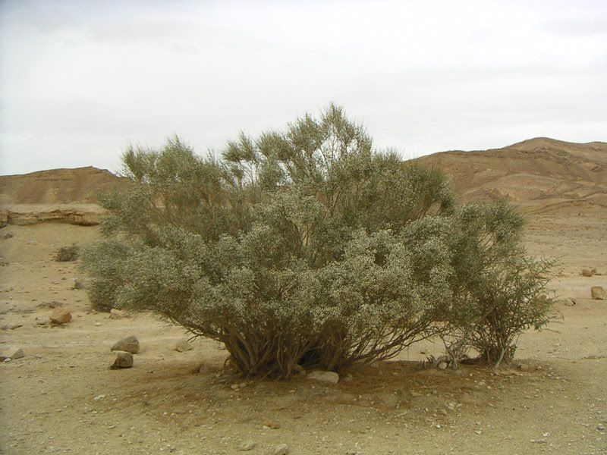

And he lay down and slept under a broom tree. And behold, an angel touched him and said to him, “Arise and eat.” And he looked, and behold, there was at his head a cake baked on hot stones and a jar of water. And he ate and drank and lay down again. 1 Kings 19:5-6

Sometimes the best thing is to rest.

And the angel of the Lord came again a second time and touched him and said, “Arise and eat, for the journey is too great for you.” And he arose and ate and drank, and went in the strength of that food forty days and forty nights to Horeb, the mount of God. 1 Kings 19:3

There he came to a cave and lodged in it. And behold, the word of the Lord came to him, and he said to him, “What are you doing here, Elijah?” 1 Kings 19:9

He said, “I have been very jealous for the Lord, the God of hosts. For the people of Israel have forsaken your covenant, thrown down your altars, and killed your prophets with the sword, and I, even I only, am left, and they seek my life, to take it away.” 1 Kings 19:10

Do you ever whine in your wilderness?

And he said, “Go out and stand on the mount before the Lord.” And behold, the Lord passed by, and a great and strong wind tore the mountains and broke in pieces the rocks before the Lord, but the Lord was not in the wind. And after the wind an earthquake, but the Lord was not in the earthquake. And after the earthquake a fire, but the Lord was not in the fire. And after the fire the sound of a low whisper. 1 Kings 19:11-12

The question or questions are often, “If God is with me, why can’t I see Him ... experience Him ... know that He is near? How can I experience His presence?”

God is present in ordinary and overlooked moments.

Why does God whisper?

Because He is right here!

The Lord is near to the brokenhearted and saves the crushed in spirit. Psalm 34:18

How can we be sure to lean in, experience and depend on God in the wilderness?

Be still some time during your day.
Be present in each moment.
Be listening for His voice.
He is here, right now, in this place, right beside you, in you, around you, enveloping you.

Where shall I go from your Spirit? Or where shall I flee from your presence? If I ascend to heaven, you are there! If I make my bed in Sheol, you are there! If I take the wings of the morning and dwell in the uttermost parts of the sea, even there your hand shall lead me, and your right hand shall hold me. Psalm 139:7–10

Take a leaf this morning and write on it one word that describes the impact or feeling you have realizing that God is with you in the valley, the wilderness, the storm, always!

