FOCUS in 2020
August 9, 2020
Dr. Jerry Edmonson, Lead Pastor
I Am Not Alone – A study in Psalm 23
And Forevermore

Over the last nine weeks, we have been deep diving into one of the most beloved Psalms in the Bible: The 23rd Psalm. A Psalm of relationship and righteousness, a Psalm of protection and provision,
a Psalm of compassion and companionship. This morning we bring our journey through the 23rd Psalm to an end as the psalmist writes in verse 6 …

and I shall dwell in the house of the Lord forever. Psalm 23:6b

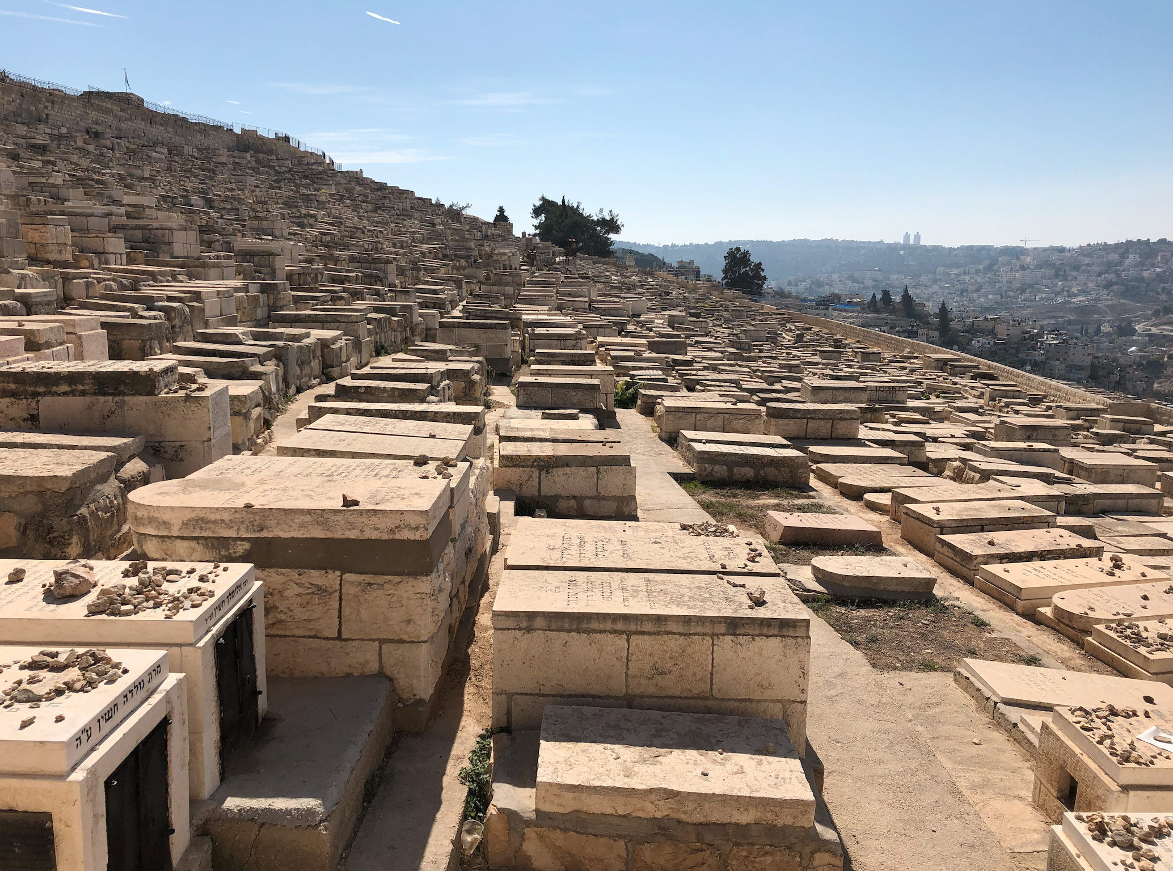

For over 3,000 years, somewhere around 150,000 Jewish people have been buried on the Mount of Olive in Jerusalem. They believe according to the Midrash (commentary and interpretation on the Jewish scriptures), that it is here that the Messiah will come and that those who are buried here will be resurrected first. The rocks represent prayers that families have prayed over their grave.
… better … the day of death than the day of birth. Ecclesiastes 7:1

For to me to live is Christ, and to die is gain. Philippians 1:21

Do you look forward to heaven? Do you see it as something to be gained?

Let us face it: in order to get to heaven, there is an event called death, which most of us do not want to think much about. But the truth is, as good as this life is at times and can be … it is also filled
with pain, trouble, loss, struggle, trials and tribulations of all sorts and this world is not our home. Jesus said …

If you were of the world, the world would love you as its own; but because you are not of the world, but I chose you out of the world, therefore the world hates you. John 15:18–19

Or as Paul writes in Philippians 3:30

But our citizenship is in heaven, and from it we await a Savior, the Lord Jesus Christ, Philippians 3:20

How do we, like David, like Paul and others, journey in this life with a longing to be with God forever? Here is the key …

Holding on to your forever family helps you live your life today.

Your spiritual family is even more important than your physical family because it will last forever. Our families on earth are wonderful gifts from God, but they are temporary and fragile, often broken by divorce, distance, growing old, and inevitably, death. Rick Warren

When we read the 23rd Psalm, there is this ease, this peace and tranquility and trust. It is as if David knows that he will make it to his forever family and his forever home because the Good Shepherd is leading and guiding, and providing for him. And so David writes … and I shall dwell in the house of the Lord forever. You see …

This life is not our end; it is our journey toward a reunion.

It is as if the 23rd Psalm is a metaphor for life. This life started in the garden of Eden where sin was birthed and death took hold of life. Filled with the Spirit’s presence, provision, protection and promise … He is leading us toward a restoration, a reunion with God – Father, Son and Holy Spirit.

When the Psalmist, who is most likely King David, writes of where he is returning to dwell, he says … “in the house of the Lord.” The house of the Lord is referred to as the sanctuary (tabernacle).

The Apostle Paul writes beautifully about this …

For we know that if the tent that is our earthly home is destroyed, we have a building from God, a house not made with hands, eternal in the heavens. For in this tent we groan, longing to put on our heavenly dwelling, … For while we are still in this tent, we groan, being burdened … He who has prepared us for this very thing is God, who has given us the Spirit as a guarantee. So we are always of good courage. We know that while we are at home in the body we are away from the Lord, for we walk by faith, not by sight. Yes, we are of good courage, and we would rather be away from the body and at home with the Lord. 2 Corinthians 5:1-8

Some day we will be in the presence of the fulness of God - Father, Son and Spirit.

It is this longing for our forever family, our forever home, that changes our priorities in this life. You might say that …

Your longing to go home changes the way you live today.

How will you live today in light of the truth that the goodness and loving kindness of God is pursuing you to the end of your life to bring you home to a reunion like none other with mothers and fathers, aunts and uncles, grandparents, friends … forever!

And I will dwell (return) in the house of the Lord (the fullness of God’s presence) forever.

Forever - to the distant horizon and again, meaning "a very distant time and even further"
Our future together is forever.

This world, this life will end, but we will be together forever.
So, what do we today?

Give your future to Jesus.

I am the living bread that came down from heaven. If anyone eats of this bread, he will live forever. And the bread that I will give for the life of the world is my flesh.” John 6:51

Spend time growing your forever family.

And the world is passing away along with its desires, but whoever does the will of God abides forever. 1 John 2:17
Even as Jesus taught …

Do not lay up for yourselves treasures on earth, where moth and rust destroy and where thieves break in and steal, but lay up for yourselves treasures in heaven, where neither moth nor rust destroys and where thieves do not break in and steal. For where your treasure is, there your heart will be also. Matthew 6:19–21

Long for the return of Christ and our family reunion.

In my Father’s house are many rooms. If it were not so, would I have told you that I go to prepare a place for you? And if I go and prepare a place for you, I will come again and will take you to myself, that where I am you may be also. John 14:2–3

